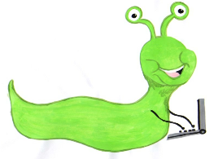

Lyng Primary School Knowledge Organiser

Online Safety



Self Image and identity

Year 3

|  |  |
| --- | --- |
| What Goldilocks and Step On words will I use? | |
| Identity | Who you are |
| Online | Using a computer/mobile device with a network connection |
| Avatar | An icon or image that represents a person |
| Username | An identification name that is not your birth name |
| Reputation | The opinions people have about a person or thing |
| Online reputation | The opinions people have about a person or thing based on their actions online. |



**Aims of this unit**

I can explain what is meant by the term ‘identity’.

I can explain how people can represent themselves in different ways online.

I can explain ways in which someone might change their identity depending on what they are doing online (e.g. gaming, using an avatar, social media) and why.

* Lesson 1 – Avatars
* Lesson 2 – Usernames online
* Lesson 3 – Changing identity online

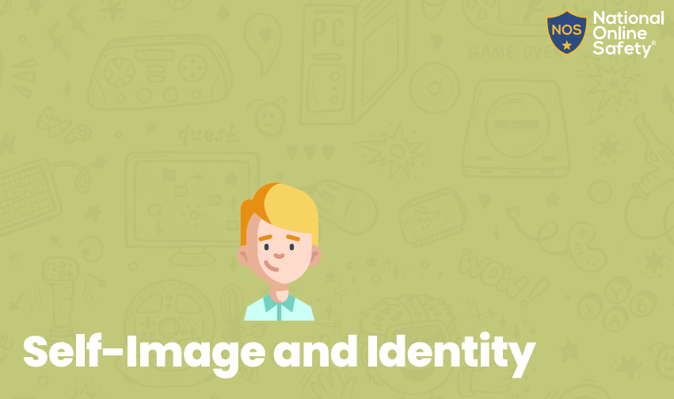

**In this unit…**

Children will learn that people may look and act differently online to the way they are in person as they use Avatars to hide their identity. Children will have scenarios of how people may look or behave differently online and how this can change how other people may feel about them. They will learn how to have a positive impact online.